Portfolio of Evidence – Part 1:
Long-Term-Short-Term Recurrent Neural Network
Submitted by:
Itumeleng Tlhale
ST10522887
Date:
07 Sep 2026

Contents
Client Report: Victorian Era Authorship Attribution Using an LSTM Recurrent Neural Network 2
Executive Summary 2
Justification for Using the Dataset for an LSTM Recurrent Neural Network 2
Dataset Overview & Basic Information 3
Exploratory Data Analysis (EDA) & Data Cleaning Outcomes 5
Data Cleaning Approach 5
Character Count After Data Cleaning 6
Sample Selection 7
Conversion to Pandas 7
Check for duplicates 7
Training the LSTM Model 8
Training and testing split 8
Author encoding 8
Tokenisation 8
LSTM Architecture 8
Train the Model 10
Interpretation of Model Training Results 11
Re-Train the LSTM Model 12
Interpretation of the Re-trained Model 12
How the Models Were Evaluated 13
What each Metric Measures 14
Conclusion: 15
References 15

Client Report: Victorian Era Authorship Attribution Using an LSTM Recurrent Neural Network

Executive Summary
This project develops a machine learning system to identify the most likely author of Victorian-era literary texts based on writing style. Using the Victorian Era Authorship Attribution dataset, Apache Spark is employed for data loading, cleaning, exploratory data analysis (EDA), and author-distribution analysis, while Python, NumPy, Pandas, and TensorFlow/Keras are used to prepare the data and build a Bidirectional LSTM neural network.
The dataset consists of 53,678 text records with two variables: text (Victorian literary passages) and author (author identifier). Analysis revealed a significant class imbalance across the 45 authors, with some authors having thousands of samples and others only a few hundred, creating a risk of model bias toward overrepresented authors.
The original LSTM model achieved a test accuracy of 48.27%, but it was limited because it used only the first 20,000 records, representing just 17 authors. To address this, the revised approach uses Spark to select up to 1,000 randomly sampled records per author, creating a more balanced and representative training dataset.
Several enhancements were introduced, including expanding the vocabulary size from 15,000 to 30,000 words, reducing sequence length from 1,000 to 500 tokens, fitting the tokenizer only on training data, increasing LSTM capacity, adding regularisation, implementing a controlled learning rate with gradient clipping, and using learning-rate reduction and early stopping to improve training performance and generalisation.
Model performance is evaluated using accuracy, precision, recall, F1-score, and a confusion matrix, allowing both overall and per-author assessment. The project also includes an authorship-prediction bot that predicts the most likely author of new text samples and provides a confidence score.
A key limitation is that the improved model must be executed before its final accuracy can be determined, as the notebook calculates results directly from actual test data rather than using estimated or unverified performance values.

Justification for Using the Dataset for an LSTM Recurrent Neural Network
The Victorian authorship dataset is well suited to an LSTM-based model because it is a supervised multi-class text classification problem, where the input variable is text and the target variable is author. The goal is to learn patterns in written passages and predict which author produced them.
Each text sample contains sequential linguistic information that reflects an author's writing style, including vocabulary choices, word combinations, sentence structure, recurring expressions, grammatical patterns, writing rhythm, distinctive phrases, and longer contextual relationships between words. Since LSTMs are specifically designed to process sequential data and capture dependencies between words across a text, they are a suitable approach for this task.
The dataset structure further supports this application, consisting of two columns: text, stored as a string containing Victorian-era passages, and author, stored as an integer representing the corresponding author. This combination of textual input and labelled author categories makes the dataset appropriate for training an LSTM to perform authorship attribution.

Dataset Overview & Basic Information
The dataset used is: Gungor_2018_VictorianAuthorAttribution_data-train.csv
The dataset was processed using Spark before being transferred to Pandas for neural-network training. The total number of records (53678) and schema were obtained directly from the Spark analysis.
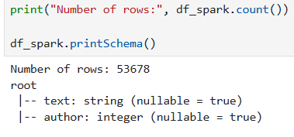
The dataset contains passages of literary text associated with numerical author identifiers. The first records displayed by Spark include text fragments associated with author 1.
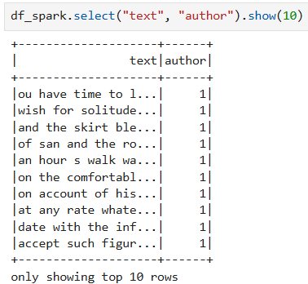
Spark was used to group the records according to author:
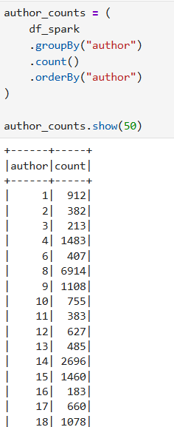
Graphical Presentation of the Author distribution:
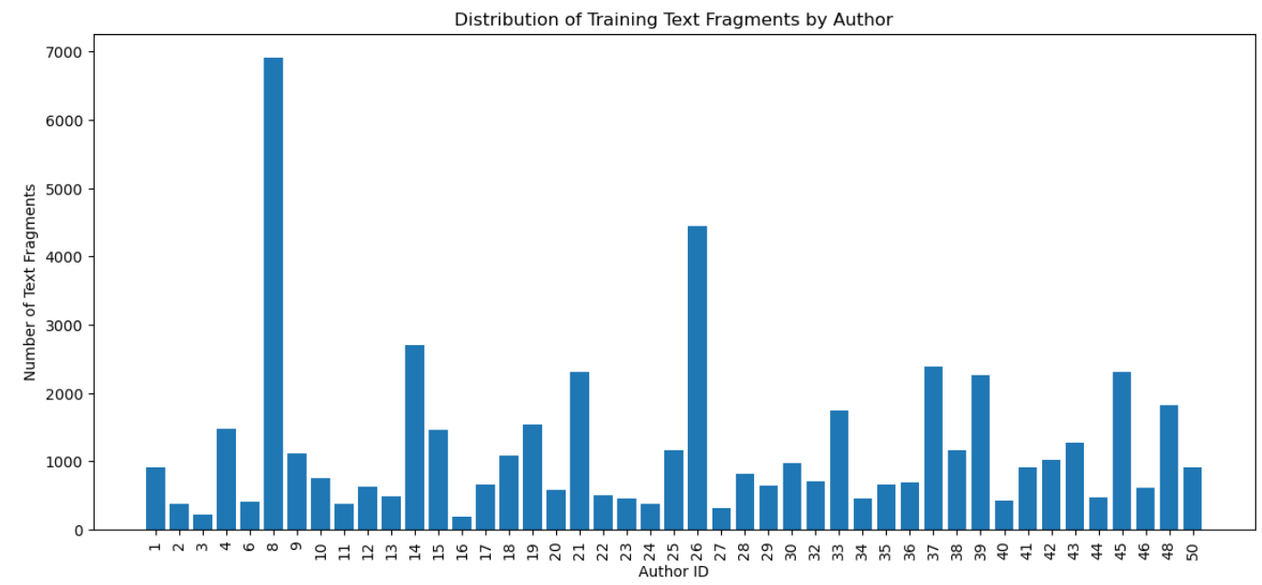
The resulting analysis identified considerable variation between authors. Author 8 has 6,914 records, author 26 has 4,441, and author 14 has 2,696, whereas several authors have fewer than 500 records.

Exploratory Data Analysis (EDA) & Data Cleaning Outcomes

Data Cleaning Approach
Data cleaning was performed using native PySpark functions rather than a Python UDF. This was an important implementation decision because it allows Spark to perform the transformations directly.
The following transformations were applied to the text:
- Convert text to lowercase.
- Remove characters that are not letters or spaces.
- Replace multiple spaces with a single space.
- Remove leading and trailing spaces.
- Store the cleaned result in a new clean_text column.
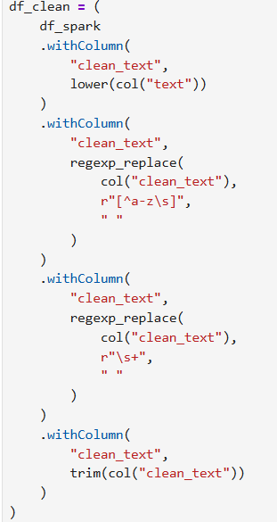

Character Count After Data Cleaning
The notebook calculated the number of characters in each cleaned text record. The output demonstrates that the records contain substantial quantities of text, with examples including character counts above 5,000.
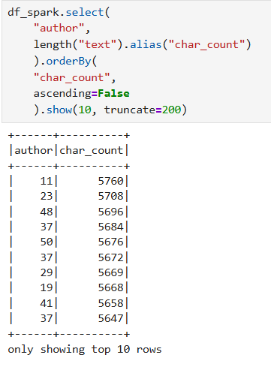

Sample Selection
Instead of fixing the number of samples, Spark was used to randomly select up to 1,000 text samples per author, providing a more representative sample of the available authors.
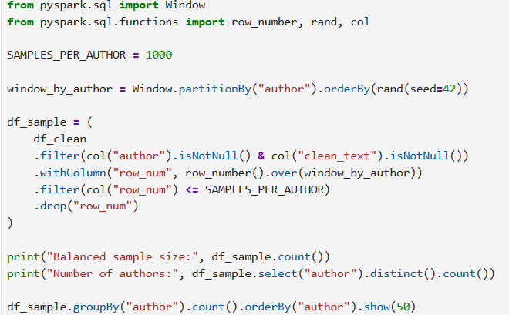

Conversion to Pandas
After Spark-based cleaning and sampling, the selected data is converted to Pandas:
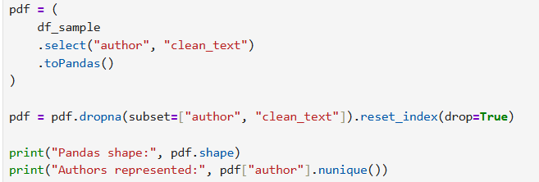
The code also checks for null rows and deletes them if available.

Check for duplicates
Duplicate rows were also checked, and none were found:
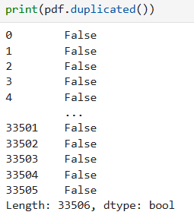

Training the LSTM Model

Training and testing split
An 80/20 split is used together with the stratification to help maintain the author distribution between the training and testing partitions.
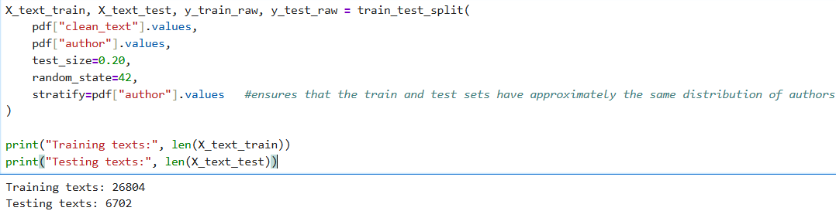

Author encoding
Encoding was done to ensure that the values can be used by the neural network.

Tokenisation
Text was converted into numerical sequences. Tokenisation was done as follows:
- maximum vocabulary: 30,000 words
- maximum sequence length: 500 tokens
- padding: post
- truncation: post

LSTM Architecture
This architecture helps the system identify patterns in text and determine the most likely author of a piece of writing. It first converts words into a format that the computer can understand, then analyses the text by looking at the sequence of words and considering both the words that come before and after each word to better understand the context. The model then refines what it has learned, while reducing the risk of relying too heavily on specific examples, and finally calculates the probability that the text was written by each possible author.
The model summary was generated from the model Architecture:
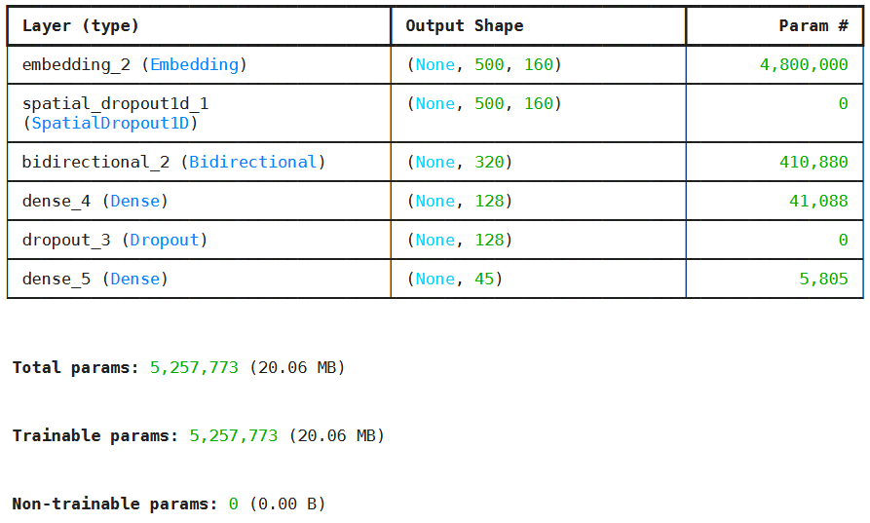
Embedding (The Translator): Words can't be read directly by computers. This first step converts words into a rich numerical dictionary. It supports a vocabulary of 30,000 words, converting each into a unique 160-point feature portrait.
Spatial Dropout (The Noise Control): Randomly turns off parts of the data during training so the model doesn't become over-dependent on specific phrase patterns. This helps it generalize well to new text it hasn't seen before.
Bidirectional Layer (The Reader): Reads sentences both forward and backward at the same time. This allows the model to understand full context, like “She sat on the bank" (forward context) with “and watched the river flow by” (backward context) means that bank is riverbank.
Dense & Dropout Layers (The Decision Refiners): Consolidates the context into key takeaways and double-checks its work by ignoring random connections to prevent memorization.
Final Dense Layer (The Classification): Outputs the final prediction by choosing the best fit among 45 target outcomes or categories.
Build Long Short-Term Memory Recurrent Neural Network (LSTM-RNN)
The following code was used to build the LSTM-RNN
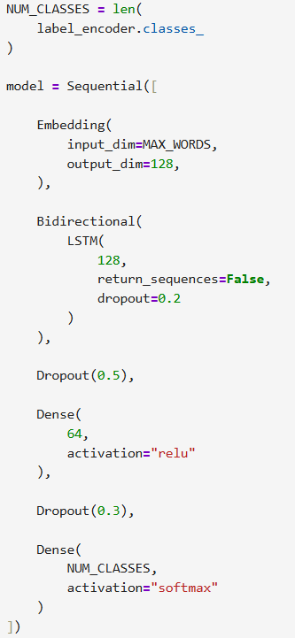

Train the Model
The following key parameters were used to train the model:
- Early Stopping: Prevents overfitting and unnecessary training
  - monitor="val_loss": Watches the validation loss during training.
  - patience=3: Stops training if validation loss does not improve for 3 consecutive epochs.
  - restore_best_weights=True: Restores the model weights from the epoch with the lowest validation loss.
- ReduceLROnPlateau: Helps the model continue learning when progress slows down
  - factor=0.5: Reduces the learning rate by 50% when improvement stalls
  - patience=1: Waits 1 epoch without improvement before reducing the learning rate.
  - min_lr=1e-5: Prevents the learning rate from going below 0.00001.
- Model(Fit): Trains the model.
  - epoch = 15: maximum number of iterations
  - batch_size = 128: Processes 128 samples before updating weight

Interpretation of Model Training Results
LSTM Training and Validation Accuracy Display
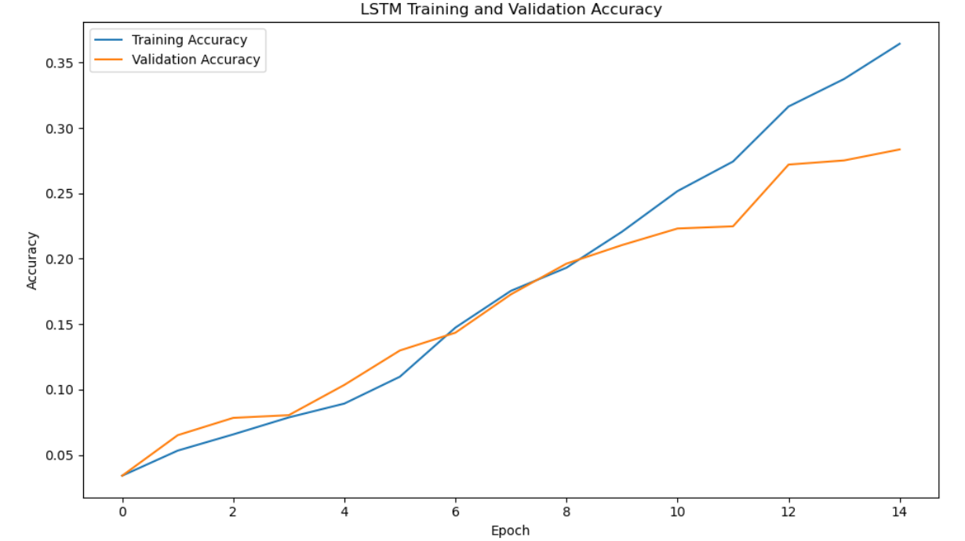
This graph shows how the model's accuracy improved over 15 training epochs (training cycles).
- The blue line represents training accuracy, which measures how well the model performs on the data it learned from.
- The orange line represents validation accuracy, which measures how well the model performs on new, unseen data.
Key Observations: The model shows good learning behaviour and only mild signs of overfitting near the end of training
.
LSTM Training and Validation Loss Display
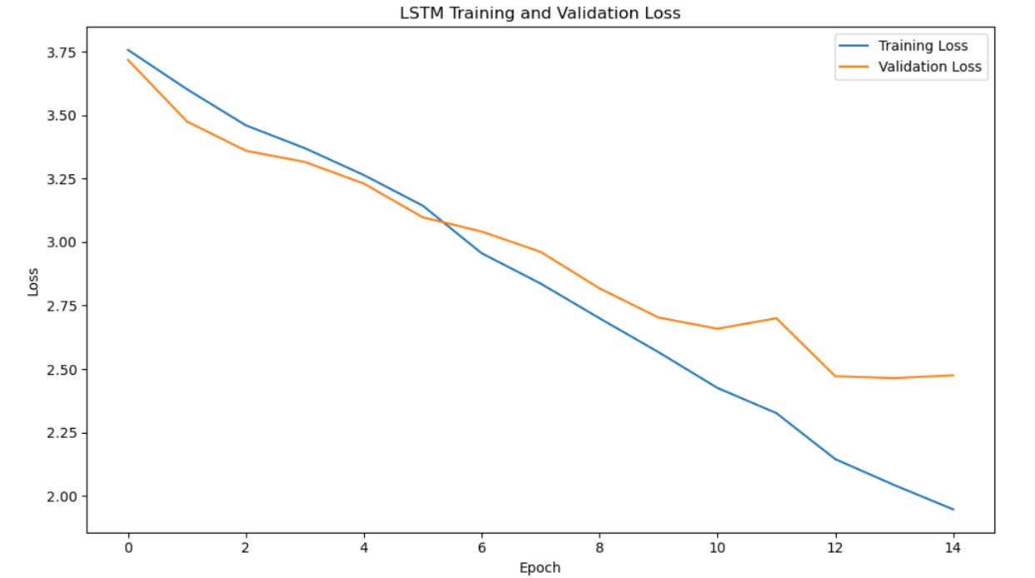
This graph shows how the model's loss (number of mistakes) changed during training.
- The blue line represents training loss, which measures how well the model learns from the study material.
- The orange line represents validation loss, which measures how well the model performs on new, unseen data.
Key Observations: the model is learning successfully, is performing better over time on both training and unseen data and shows only mild overfitting near the end of training.

Re-Train the LSTM Model
The parameters that we changed during the retrain are:
- Early Stopping:
  - patience=5: Stops training if validation loss does not improve for 5 consecutive epochs.
- ReduceLROnPlateau:
  - min_lr=1e-6: Prevents the learning rate from going below 0.000001.
- Model(Fit): Trains the model.
  - epoch = 30: maximum number of iterations

Interpretation of the Re-trained Model
Re-trained LSTM Training and Validation Accuracy Display
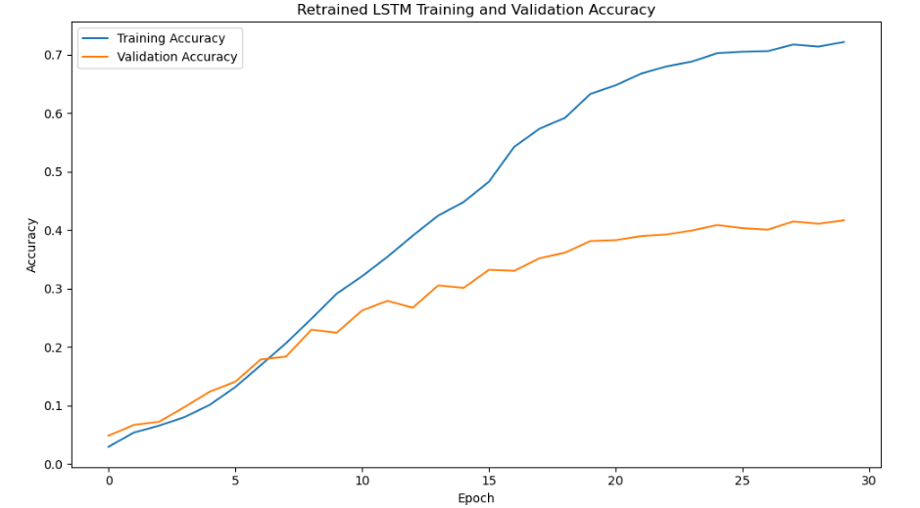
This graph shows how the model's accuracy changes over 30 training epochs
Key Observations: The model is learning successfully, but the growing gap between training and validation accuracy indicates moderate overfitting, with limited gains in validation performance after Epoch 15.
Re-trained LSTM Training and Validation Loss Display
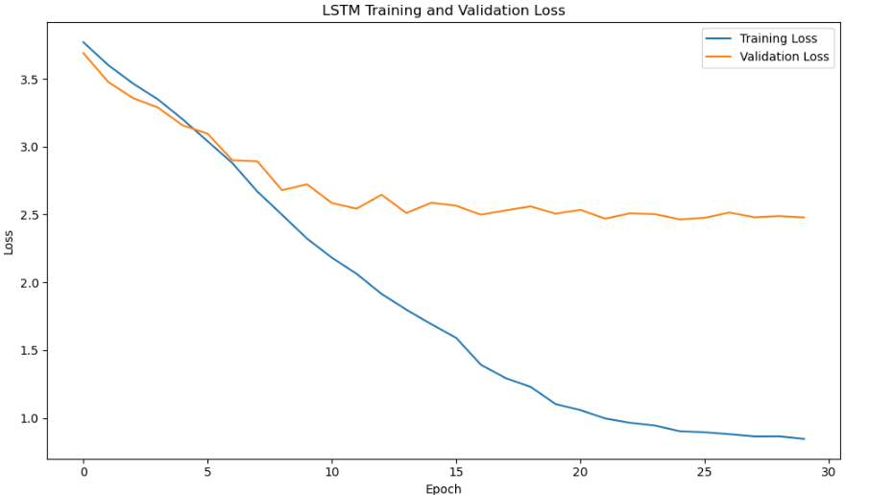
Key Observations: Key Observations: The model learned the training data well, but validation performance stopped improving significantly after about Epoch 15, suggesting overfitting and that training could have been stopped earlier using Early Stopping.

How the Models Were Evaluated
Classification reports were generated for the Initial and Re-trained models, using the code below:
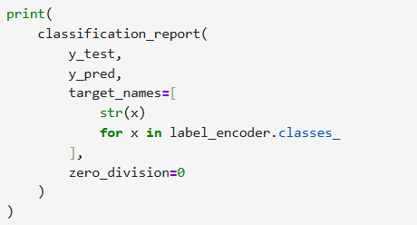
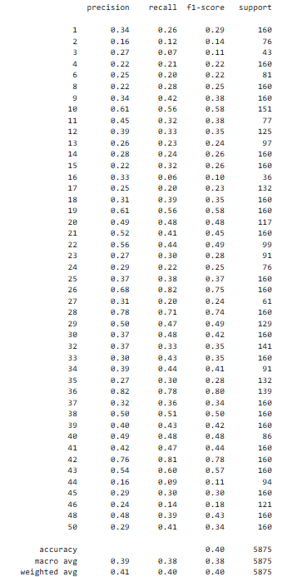
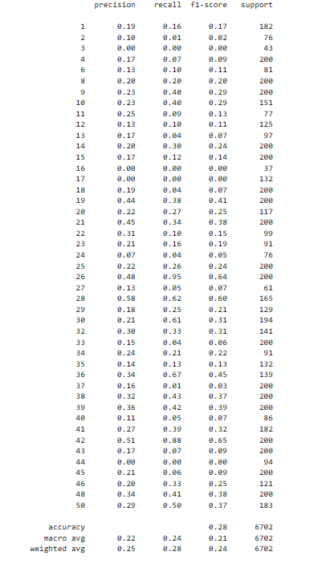
Initial Model Re-trained Model

What each Metric Measures
Accuracy: Measures the percentage of all predictions that were classified correctly. Higher accuracy means the model makes more correct predictions overall.
Precision: Measures how many of the predicted instances for a class were actually correct.
Recall: Measures how many of the actual instances of a class were correctly identified
F1-Score: Combines Precision and Recall into a single measure
Macro F1: Calculates the F1-score for each class and then averages them equally.
Weighted F1: Calculates the F1-score for each class and weighs it according to the number of samples in that class.
Model Comparison
Metric | Initial Model | Re-trained Model | Improvement
Accuracy | 28% | 40% | 12%
Macro F1 | 21% | 38% | 17%
Weighted F1 | 24% | 40% | 16%
Precision (Weighted Avg) | 25% | 41% | 16%
Recall (Weighted Avg) | 28% | 40% | 12%

Conclusion:
Re-trained model 2 is the preferred model for deployment and further development. It demonstrates significant improvements across every major evaluation metric, particularly the F1 scores, which are generally the most informative metrics for multi-class classification problems. The higher Macro F1 score also indicates that Re-trained model generalizes better across different classes rather than only performing well in the majority classes. (Scikit-learn Developers, 2025)

References
Scikit-learn Developers, 2025. precision_recall_fscore_support. [Online]
Available at: https://scikit-learn.org/stable/modules/generated/sklearn.metrics.precision_recall_fscore_support.html#sklearn.metrics.precision_recall_fscore_support
[Accessed 05 08 2026].

